**DESIGN OF SMART CITIES**

**Project - I**

**“Air Quality Monitoring In Delhi During Winters”**

*Submitted in partial fulfillment of the requirements for the degree of*

**Bachelor of Technology**

***in***

**Computer Science and Engineering**

*by*

|  |  |
| --- | --- |
| **21BCE3913** | **DHERYA CHAUDHARY** |
| **21BCT0426** | **ARYAN BALAJI** |
| **21BCE0540**  **21BCE3791** | **ADITYA NAYAK**  **HARSHIT AMRESH** |

**Under the Supervision of**

|  |
| --- |
| **DR. SWARNALATHA P** |
|  |
| School of Computer Science and Engineering (SCOPE) |

**INTRODUCTION**

Delhi's air quality has reached critical levels, especially during the winter season, when the concentration of harmful particulate matter surges due to factors like crop residue burning, vehicle emissions, and industrial pollution. This presentation explores how advanced sensor technologies can be integrated as a forward-looking solution to monitor, evaluate, and tackle air pollution effectively. Real-time air quality sensors offer continuous and precise tracking of dangerous pollutants, enabling government bodies, environmental organizations, and citizens to respond swiftly and make informed decisions. The insights gathered from these sensors not only inform smarter environmental policies but also help identify pollution hotspots and raise public awareness about associated health risks and preventive steps. By strategically deploying sensor-based systems, Delhi can take a significant step toward cleaner air, better public health, and a more sustainable and resilient urban ecosystem for both present and future generations.

This presentation highlights the transformative role of advanced sensor technology in actively monitoring and combating air pollution. Real-time sensors deliver continuous, accurate pollutant data, empowering authorities and citizens to take swift, informed action. These insights drive smarter environmental policies, pinpoint pollution hotspots, and promote public awareness on health impacts. With strategic deployment, sensor-based systems pave the way for cleaner air, improved health, and a more sustainable future for Delhi.

**LITERATURE REVIEW**

Air pollution—particularly from particulate matter (PM)—remains a major concern in densely populated urban environments. PM2.5 and PM10 particles are among the most harmful air pollutants, capable of penetrating deep into the lungs and bloodstream, leading to respiratory and cardiovascular diseases. According to the World Health Organization (WHO), air pollution causes approximately 7 million premature deaths worldwide each year, with urban areas being the most affected due to high traffic density, industrial emissions, and construction activities. To address this challenge, researchers and urban planners are increasingly turning to smart city frameworks that integrate real-time air quality monitoring systems. These systems use advanced sensors to continuously collect data on pollutant levels, enabling quicker responses to pollution spikes and more effective long-term strategies. A study by Saha and Singh (2017) underscores the critical role of such technologies in promoting sustainability. They argue that smart city initiatives, when equipped with real-time air quality monitoring, not only raise public awareness but also empower authorities to implement targeted interventions. By embedding sensor networks within urban infrastructure—such as traffic lights, street lamps, and public transportation—cities can track pollution patterns more accurately. This data-driven approach facilitates more responsive policy decisions, better health outcomes, and progress toward a cleaner, more sustainable urban environment. Building on this perspective, Saha et al. (2020) investigated the environmental impact of smart city initiatives in New Delhi, highlighting the pivotal role that IoT-based technologies play in reducing pollution levels. In a related study, Saha et al. (2019) introduced a comprehensive model for future smart cities, emphasizing the importance of IoT-enabled monitoring systems for tracking both particulate matter and gaseous pollutants.

Similarly, Miles et al. (2018) developed a decision support system that leverages IoT for real-time monitoring and analysis of air quality, demonstrating how such systems can facilitate timely and informed decision-making. This approach is in line with the findings of Stankovic et al. (2012), who explored the use of smart technologies to address traffic-related air pollution in urban settings.

Additionally, Dwevedi et al. (2018) highlighted the critical role of big data in enhancing the functionality of smart cities. They argued that integrating air quality sensors with advanced data analytics can significantly improve policy formulation and urban planning.

**PROBLEM FORMULATION**

Urban areas are facing escalating levels of air pollution due to increasing vehicular traffic, industrial emissions, and other anthropogenic sources. Among the most harmful pollutants are particulate matter (PM1.0, PM2.5, PM10), which pose significant health risks including respiratory and cardiovascular illnesses. However, current air quality monitoring systems are often costly, lack scalability, and fail to deliver real-time, high-resolution data necessary for timely intervention. There is a pressing need for an affordable, accurate, and real-time air quality monitoring solution that can be seamlessly integrated into smart city infrastructures to better inform policy decisions, raise public awareness, and mitigate health impacts.

**RESEARCH PROBLEM**

This project aims to design an IoT-based air quality monitoring system that can precisely track particulate matter levels, temperature, and humidity in real time. The system will leverage cloud integration for seamless data storage and provide user-friendly visualizations, supporting data-driven public health strategies and informed urban planning decisions.

**RESEARCH OBJECTIVE**

The goal is to develop a cost-effective and scalable IoT-driven solution for continuous air quality monitoring, incorporating real-time data acquisition, cloud-based data management, and clear visualizations of environmental metrics—enabling informed decision-making to improve air quality in contemporary urban settings.

**PROPOSED MODEL**

The system employs a PMS5003 sensor to accurately measure levels of particulate matter in the air. An Arduino Uno microcontroller processes the collected data, while a dedicated power supply ensures stable operation. For output and communication, the system features an LCD screen for real-time air quality display, a data logger for storing historical data, and a GPRS modem that enables remote data transmission. This setup supports continuous, accessible, and efficient air quality monitoring.

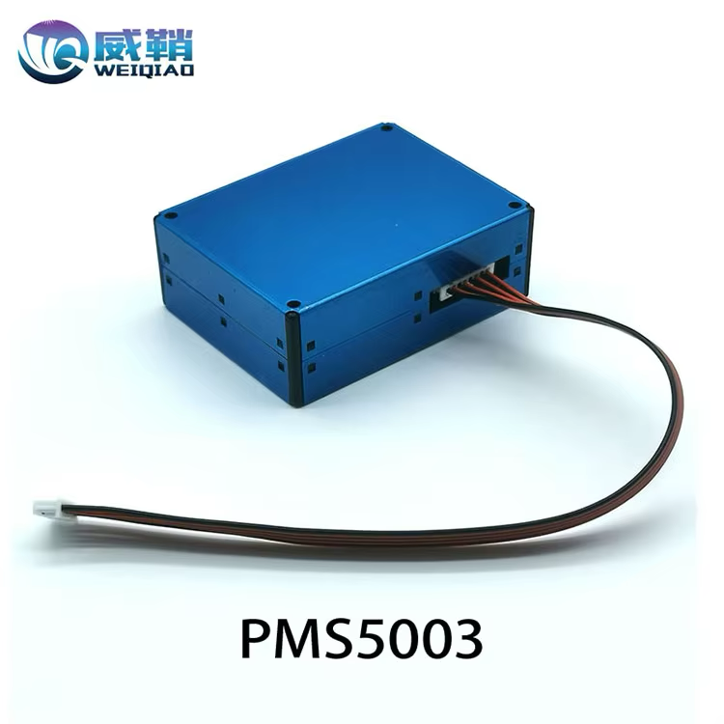

**ADVANTAGES OF THE MODEL**

The PMS5003 sensor offers several advantages over other particulate matter sensors, making it ideal for real-time air quality monitoring. It provides high accuracy and stability in detecting PM1.0, PM2.5, and PM10 concentrations using laser scattering technology. Unlike many low-cost sensors, the PMS5003 delivers reliable data with minimal calibration and features a built-in fan to maintain consistent airflow, enhancing measurement precision. Its compact design, low power consumption, and UART communication interface make it highly suitable for integration into IoT-based systems, especially in smart city and portable applications.

**DISADVANTAGES OF THE MODEL**

Despite its many strengths, the PMS5003 sensor also has some limitations. One key disadvantage is its sensitivity to environmental factors like humidity and temperature, which can affect the accuracy of readings if not properly compensated. Additionally, the laser and fan components may degrade over time, reducing long-term reliability. The sensor also requires regular maintenance, such as cleaning, to prevent dust accumulation that could interfere with performance. Moreover, while suitable for general monitoring, it may not meet the stringent accuracy standards required for regulatory or industrial-grade air quality assessments.

**ARCHITECTURE DIAGRAM**

**ANALYTICAL DESCRYPTION**

**Data Collection and Analysis**

The PMS5003 sensor continuously collects real-time data on particulate matter, specifically measuring concentrations of PM1.0, PM2.5, and PM10—particles with diameters smaller than 1.0, 2.5, and 10 micrometers, respectively. This data provides valuable insights into air quality trends, such as daily pollution patterns, peak levels during rush hours, or spikes linked to specific weather conditions. Additionally, it can highlight variations in air quality across different locations. With a consistent data stream, the system can conduct detailed statistical analyses—calculating daily averages, monitoring long-term trends, and detecting anomalies or sudden increases in pollution levels.

**Sensor Calibration and Accuracy**

To ensure the accuracy of the readings, the PMS5003 sensor may require calibration. Environmental factors such as temperature, humidity, and air pressure can influence its measurements. Calibration involves comparing the sensor’s output with that of a high-precision reference-grade device to determine any deviations or inaccuracies. Based on this comparison, software-based correction factors or calibration tables can be implemented to adjust the readings, enhancing the reliability and precision of the data collected.

**Data Processing and AQI Calculation**

The raw particulate matter data collected by the PMS5003 sensor is processed and translated intoa more understandable format using the Air Quality Index (AQI). This index provides a standardized scale to represent air quality, making it easier for users to interpret pollution levels. Each measured pollutant concentration—such as PM2.5 or PM10—is mapped to a corresponding AQI value based on recognized guidelines, such as those provided by the U.S. Environmental Protection Agency (EPA) or the World Health Organization (WHO). This mapping helps categorize air quality into intuitive levels such as “Good,” “Moderate,” “Unhealthy,” and so on, allowing users to quickly assess potential health risks.

**Alert Generation**

The system is designed to automatically generate alerts based on pre-defined AQI thresholds. When pollution levels exceed safe limits, it can issue real-time warnings to inform users of deteriorating air quality. For instance, if PM2.5 levels rise above 100 μg/m³, the system can trigger an “Unhealthy Air Quality” alert. These notifications can prompt users to take protective measures, such as staying indoors, avoiding strenuous outdoor activity, or wearing protective masks. This feature is crucial for ensuring public awareness and enabling timely health precautions during pollution spikes.

**THEORETICAL DESCRYPTION**

**FORMULA USED**

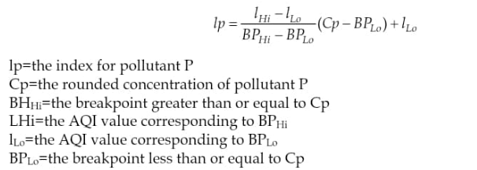

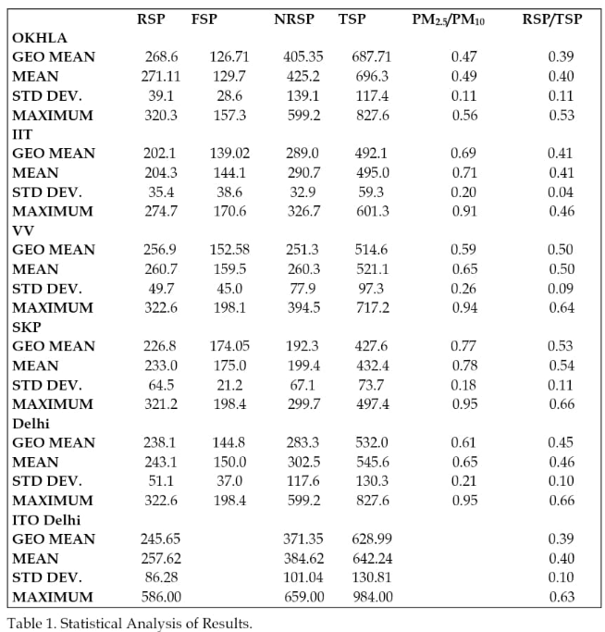

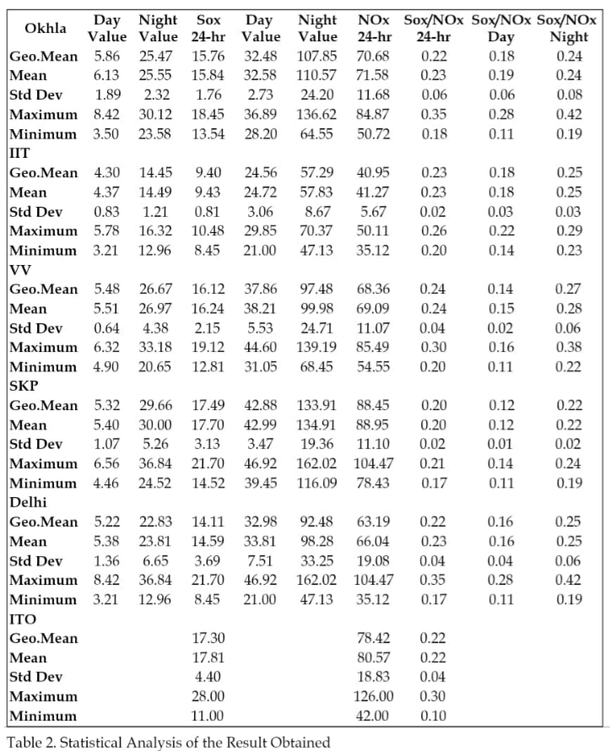

**Principles of Particulate Matter Detection**

The PMS5003 sensor operates using the principle of laser scattering to detect airborne particulate matter. Inside the sensor’s detection chamber, a laser beam is emitted. As particles in the air pass through this beam, they scatter the light in different directions. A photodetector captures this scattered light, and by analyzing the intensity and angle of the scattering, the sensor can estimate both the size and number of particles present. This detection method is based on Mie scattering theory, which describes how particles of a size like the wavelength of light interact with and scatter that light. This principle enables precise and real-time particulate matter measurement.

**Size Differentiation**

The PMS5003 sensor is capable of distinguishing particles based on size specifically PM1.0, PM2.5, and PM10. This classification is essential for understanding the health implications of different particle sizes. PM2.5 particles, for example, are particularly harmful because they are small enough to bypass the body's natural respiratory defenses, reach deep into the lungs, and even enter the bloodstream. The scientific basis for this lies in concepts such as aerodynamic diameter and respiratory deposition, which describe how particles behave within the airways and where they are likely to settle within the respiratory tract, influencing their health impact.

**Air Quality Index (AQI) Conversion**

The Air Quality Index (AQI) is a standardized metric used to communicate air pollution levels in relation to their potential health impacts. Converting raw particulate matter data—such as PM2.5 or PM10 concentrations—into AQI values involves applying mathematical formulas derived from epidemiological and environmental health studies. For instance, a PM2.5 concentration of 35 μg/m³ may correspond to an AQI value of 100, which falls into the “Moderate” category. AQI values are segmented into clear categories like “Good,” “Moderate,” “Unhealthy,” and more, each typically associated with a specific color code. This categorization makes it easier for the public to quickly assess air quality conditions and take appropriate health precautions.

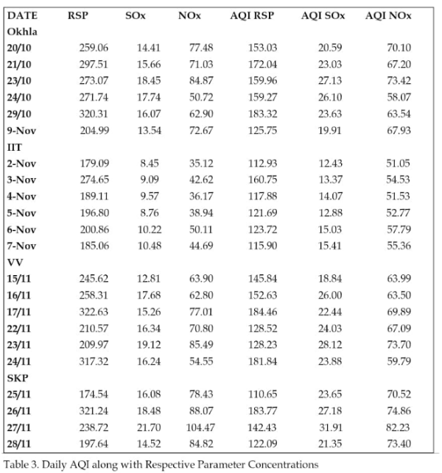

**System Design Theory**

The system is built upon fundamental Internet of Things (IoT) principles, with the PMS5003 sensor functioning as a key component in a broader, interconnected network. In theory, the system architecture consists of several layers: data acquisition (sensor readings), data transmission (via Wi-Fi, GSM, or other communication protocols), cloud-based storage, and data processing and visualization. Additional architectural components may include security layers for protecting data integrity, user interfaces for real-time monitoring, and scalability provisions to allow easy integration of more sensors or the monitoring of additional environmental factors such as temperature, humidity, or gas levels. Furthermore, by leveraging cloud computing, the system can perform advanced analytics and support machine learning models to predict future air quality trends, enabling smarter and more proactive environmental management.

**Strengths and Weaknesses of Available Air Quality Datasets**

Until the start of 2018 the Indian monitoring network had limited extent. Very few stations have operated continuously from 2015 to the present. The number of stations in the continuous monitoring network has increased dramatically since 2017 (Fig. 2) making it far more feasible now to evaluate air quality across India than in the past. However, spatial coverage is still limited till now.

**Fig. :** Methodology used to create a representative data series for each pollutant which provides daily, monthly, seasonal and annual average concentrations.

**Fig. 2.** Number of CAAQM stations providing valid hourly concentrations across India, between 2015–2019, for PM10, PM2.5, SO2, NO2 and O3, respectively.

**Fig. 3.** Valid hourly CAAQM observations (as a percent of total hours) of PM10, PM2.5, SO2, NO2 and O3 at each station in a given year between 2015 and 2019.

## **Spatial Distribution of Air Pollutants from 2015–2019**

The general distribution pattern of air pollution, showing higher pollution levels in northern than southern India, is captured in both the manual and continuous monitoring station data.

**Fig. :** Spatial distribution of annual average (2015–2019) concentrations (µg m–3) of PM10, PM2.5, SO2, NO2 and maximum daily average 8-hour (MDA8) O3 from the CPCB CAAQM continuous monitoring stations that meet our criteria for data inclusion (see methods for details). Each dot represents a single station. The number of stations for each species in each year is indicated in parentheses.

**Fig. :** Spatial distribution of reported annual average (2015–2018) concentrations (µg m–3) of PM10, PM2.5, SO2 and NO2 from NAMP manual stations (including all available observations). Each dot represents a single station. The number of stations in each year is indicated in parentheses.

**Seasonal and Monthly Patterns of Air Pollutants**

Annual average concentrations (µg m–3) of PM10, PM2.5, NO2, and SO2, and MDA8 O3 concentrations from all CAAQM stations available in all years from 2015 through 2019 that meet our analysis criteria. Monitoring stations on the x-axis are arranged from north to south. New stations added after 2015 are not included and only stations operating in 2015 and thereafter that met our analysis criteria in all five years are included here. CPCB and WHO ambient air quality standards are shown in magenta and blue dotted lines, respectively. See Fig. 6 for details of standards. For the latitude and longitude of these stations, see Table S4.

**Case Studies of Kolkata, Delhi, Mumbai, Chennai & Hyderabad**

Delhi, Kolkata, Mumbai, Hyderabad and Chennai are the five cities in India in which the U.S. State Department Air-Now network real time monitoring stations record PM2.5 concentrations at the US embassy and consulates. In these five cities, we compare daily and monthly mean PM2.5 measurements from the Air-Now and CAAQM networks. Fig. 10 shows scatterplots between daily.

It shows Scatter plots of daily mean PM2.5 concentrations comparing Air-Now observations from the five cities in which they exist with all CPCB CAAQM monitors in those cities, between 2015– 2019. For each plot the regression line (solid), regression equation and r value for each correlation are shown for each city. The dashed grey line indicates 1:1 correspondence. The inset plots are scaled to the data range.

## **Growing Dataset and Existing Gaps**

Prior to 2015 surface air quality monitoring data was available from only a few stations in India. Over the period we analyzed, 2015–2019, the number of monitoring stations across India increased dramatically. Our compilation and rigorous quality control of these data provide, for the first time, a comprehensive dataset of criteria pollutants that can be used to evaluate air pollutant concentrations simulated by atmospheric chemical transport models, satellite retrievals and reanalysis. Our dataset also provides a baseline for the NCAP. Previous studies have used ground observations from selected locations without transparently addressing existing data gaps and are not clear in their evaluation and quality assurance of surface observations. Here, we have carefully evaluated the archived data for completeness and accuracy, discarding values in excess of instrumental range, and requiring representative temporal coverage for each averaging period at each monitor. For example, for inclusion in our analysis a monitor measuring a species we analyze must report daily averages at least one hour per 12-hour daytime or night-time period, eight days for each monthly average, and one month per quarter and atleast two quarters for each annual average (see Tables S2(a), S2(b) and S3). However, spatial coverage remains spotty with monitoring stations predominantly located in large cities; smaller cities and rural locations lack coverage. Further expansion of the monitoring networks to facilitate an improved understanding of spatial distributions of pollutants across urban/rural India and to evaluate future trends in pollutant concentrations is needed. Very few stations provide valid observations continuously from 2015 onwards limiting our ability to analyze past trends in air quality. However, trend analyses starting in 2018 will be valuable and possible in the future.

## **Differences in Air Quality Observations**

We compare monthly, seasonal and annual mean concentrations of air pollutants we analyze with other studies that have analyzed surface measurements of the same pollutants, cities and time periods across India (Table S5). We find that the range of concentrations of criteria pollutants reported in our analysis of CPCB data are similar to the values presented in research studies using ground observations during the same period (Kota *et al.*, 2018; Sreekanth *et al.*, 2018; Guttikunda *et al.*, 2019; Mahesh *et al.*, 2019; Ravinder *et al.*, 2019; Jain *et al.*, 2020; Tyagi *et al.*, 2020; Jat *et al.*, 2021). However, as shown in Table S5, in case studies covering extreme events and studies in bigger cities and more polluted regions, like Delhi and the IGP, differences exist between the CPCB concentrations we calculate and those reported in the literature from surface monitoring stations, models and satellite data (Kota *et al.*, 2018; Tyagi *et al.*, 2019; Jat *et al.*, 2021).

Above Image shows Satellite derived annual surface PM2.5 concentration overlaid with CAAQM network surface measurements (circles), from 2015–2019.

**GAPS IDENTIFIED**

1. **Limited Spatial Coverage**:
   * Monitoring stations are concentrated in urban areas, with virtually no data from rural regions where biomass burning and household emissions are significant.
   * High-pollution smaller towns and regions like the Indo-Gangetic Plain (IGP) are under-monitored.
2. **Temporal Gaps and Inconsistencies**:
   * Many monitoring stations did not provide continuous or complete data for the entire 2015–2019 period.
   * Lack of historical continuity makes long-term trend analysis difficult.
3. **Data Quality Challenges**:
   * Variability in data completeness and consistency required extensive quality control.
   * CPCB monitors cap PM2.5 readings at 999.99 µg/m³, underestimating values during extreme events like Diwali.
4. **Rural Air Quality Neglected**:
   * No data exists from rural regions, despite significant pollution from agricultural burning.
5. **Insufficient Ground Validation**:
   * Satellite data and models are validated primarily with urban ground monitors, potentially limiting accuracy for broader applications.
6. **Inter-Pollutant Interactions Unexplored**:
   * Ozone patterns were observed to be similar across cities despite varying PM and NO2 levels — a phenomenon left unexplored.

**HARDWARE TOOLS REQUIRED**

* **Sensor – PMS5003:**

A laser-based particulate matter sensor capable of accurately measuring concentrations of PM2.5 and PM10 in the air. It serves as the primary sensing element for detecting airborne particles.

* **Microcontroller – ESP8266/ESP32:**

A Wi-Fi-enabled microcontroller responsible for acquiring data from the PMS5003 sensor and transmitting it to a cloud server or remote monitoring platform. The ESP32 variant offers additional processing power and Bluetooth support if needed.

* **Power Supply – Battery or USB Power Source:**

Provides the necessary power to both the microcontroller and the sensor. The system can be powered using a rechargeable battery for portability or a USB connection for continuous operation.

* **Display – I2C LCD Display:**

A compact and efficient display module used to show real-time readings of PM2.5 and PM10 values, allowing users to monitor air quality directly from the device.

**SOFTWARE TOOLS REQUIRED**

**Arduino IDE :** Used for programming and uploading code to the ESP8266/ESP32 microcontroller.

* ThingSpeak: Cloud IoT platform for data visualization and storage.
* Blynk: Mobile app platform for real-time data visualization and alerts.
* Libraries: PMS.h: Library for interacting with the PMS5003 sensor.
* ESP8266WiFi/ESP32WiFi: Wi-Fi library for ESP modules.
* ThingSpeak.h (or Blynk.h if using Blynk): For cloud communication.
* LiquidCrystal_I2C.h : For displaying data on an I2C LCD.

**CIRCUIT DIAGRAM**

**CODE**

#include <LiquidCrystal.h>

LiquidCrystal lcd(12, 11, 5, 4, 3, 2);

int pin8 = 8;

int analogPin = A0;

int sensorValue = 0;

void setup() {

pinMode(analogPin, INPUT);

pinMode(pin8, OUTPUT);

lcd.begin(16, 2);

lcd.print("What is the air ");

lcd.print("quality today?");

Serial.begin(9600);

lcd.display();

}

void loop() {

delay(1000);

sensorValue = analogRead(analogPin);

Serial.print("Air Quality in PPM = ");

Serial.println(sensorValue);

}

if (sensorValue <= 100)

{

Serial.print("Fresh Air ");

Serial.print ("\r\n");

lcd.setCursor(0, 1);

lcd.print("PM 10");

}

else if (sensorValue >= 100 && sensorValue <= 200)

{

Serial.print("Poor Air");

Serial.print ("\r\n");

lcd.setCursor(0, 1);

lcd.print("PM 2.5");

}

else if (sensorValue >= 200)

{

Serial.print("Very Poor Air");

Serial.print ("\r\n");

lcd.setCursor(0, 1);

lcd.print("PM 1.0");

}

if (sensorValue > 200) {

digitalWrite(pin8, HIGH);

}

else {

digitalWrite(pin8, LOW); }

**OUTPUT**

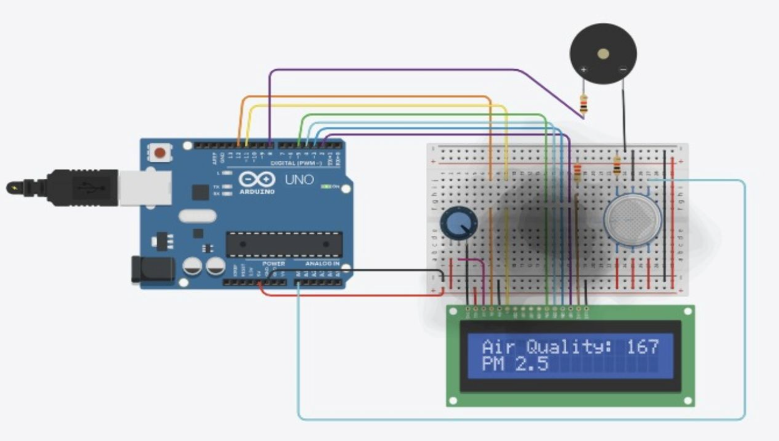

**CONCLUSION**

The IoT-based Air Quality Monitoring System represents a powerful step forward in the fight against urban air pollution, leveraging cutting-edge technology to deliver real-time environmental data and actionable insights. As cities grow and industrial activities increase, air pollution has become a silent threat to public health and ecological balance. This project directly addresses that concern by offering a smart, scalable solution capable of monitoring particulate matter and environmental conditions continuously and accurately. By harnessing the potential of the Internet of Things (IoT), the system enables instant data collection, cloud-based storage, and intuitive visualizations that help stakeholders—from city planners to environmental agencies—make informed decisions. It empowers authorities to identify pollution hotspots, respond swiftly to air quality deteriorations, and develop long-term strategies for cleaner, healthier urban living.

What sets this project apart is its alignment with the United Nations’ Sustainable Development Goals (SDGs). It contributes significantly to SDG 3 (Good Health and Well-being) by minimizing exposure to hazardous air pollutants; SDG 11 (Sustainable Cities and Communities) through smarter, greener infrastructure; and SDG 13 (Climate Action) by promoting environmental awareness and proactive climate responses. Furthermore, the affordability and adaptability of the system make it suitable for widespread deployment—from school zones and residential areas to traffic-heavy regions and industrial zones. Its real-time capabilities encourage citizen participation, raising awareness and fostering collective responsibility toward cleaner air. In essence, this IoT-powered monitoring system not only serves as a technological advancement but also as a catalyst for change—bridging the gap between environmental data and actionable impact. It’s a step toward building cities that are not only smart but also sustainable, healthy, and future-ready.

**PROJECT IMPACT ON SOCIETY**

* **Society :** The project improves public health by providing real-time air quality data, enabling better decision-making to mitigate air pollution risks.
* **Environment :** It contributes to the creation of cleaner urban environments, helping reduce air pollution levels, thus supporting environmental sustainability.
* **Social Awareness :** The project fosters awareness about air quality issues, encouraging people to take proactive steps in reducing their environmental footprint.

**REFERENCES**

* Saha & Singh (2017): Assesses Delhi’s preparedness for smart city development with a focus on sustainability and inclusivity.
* Saha et al. (2020): Explores environmental visualization for smart urban planning in New Delhi.
* Gopalaswami (2016): Analyzes how weather and traffic contribute to air pollution in Delhi.
* Miles et al. (2018): Proposes an IoT-based system for monitoring and mitigating air pollution in smart cities.
* Jain et al. (2018): Identifies key sources of PM10 pollution in Delhi using advanced statistical models.
* Yadav et al. (2019): Studies pollutant sources in a future smart city and recommends integrated control measures.
* Dwevedi et al. (2018): Highlights the role of big data in environmental monitoring for smart Indian cities.
* Stankovic et al. (2012): Presents a case study on sustainable traffic-related air pollution management in Banja Luka.
* NDMC Smart City Ltd. (2023): Provides an overview of smart infrastructure projects in New Delhi.
* Ministry of Urban Development (2021): Lays out the urban development blueprint for Delhi’s sustainable future.